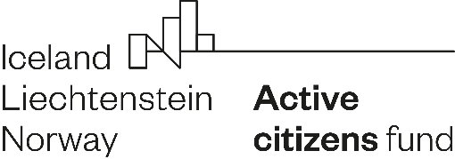

Declaration of Partnership

I. Applicant - leader
Name of the Applicant
in Polish
Name of the Applicant
in English
Register name
and registration number
Project title in Polish
Project title in English

II. Partner
Name of the Partner
Address
Register name
and registration number1 (if applicable)
Information about own contribution made by the Partner* | Partner  (a) provides all or part of its own financial contribution,  (b) provides all or part of its own non-financial contribution,  (c) does not provide any form of own contribution.
* Please, delete the inapplicable one.

III. Declaration

We declare partnership cooperation in the implementation of the project presented
in application no. [application number] submitted under the Active Citizens Fund - National programme, financed from the EEA Funds.

The partner declares:
- participation in the preparation of the project and being familiar with its description presented in the application no. [application number];
- in case of receiving a grant, undertakes to sign a partnership agreement and to carry out tasks within the framework of partnership cooperation in project implementation.

The Partner's tasks, corresponding to Partner’s knowledge and competences, are following:
1. [content of the task and deadline for implementation]
2. [content of the task and deadline for implementation].

At the same time, we declare that our declaration of partnership results from a voluntary desire to participate in activities for the common good and it is not profit oriented. We also declare that none of our entities is a founder, partner or shareholder of the other, and there is no personal connection between our entities - the same people are not members of our management or supervisory bodies.

[OPTIONAL - IN CASE THE PARTNER WILL BENEFIT FROM THE GRANT FUNDS]
Moreover, we declare that we are familiar with the principles of using, accounting
and documenting the received grant.

Name(s) of person(s) authorised
to represent the Partner
Date and signature(s)
Name(s) of the person(s) authorised
to represent the Applicant
Date and signature(s)

In case: associations, unions of associations, foundations, social cooperatives, non-profit companies, rural housewives circles (independent agricultural circle) and church legal persons, please provide the National Court Register number. In case: ordinary associations and rural housewives' associations (registered with the Agency for Restructuring and Modernisation of Agriculture), please provide the name of the poviat in which the entity is registered.

