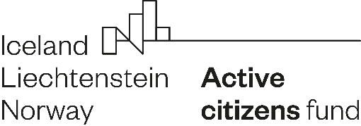

Declaration of Partnership

I. Applicant - leader
Name of the Applicant
in Polish
Name of the Applicant
in English
National Court Register number
Project title in Polish
Project title in English

II. Partner
Name of the Partner
Address
Register name
and registration number¹ (if applicable)
Information about own contribution made by the Partner* | Partner  - does not provide any form of own contribution,  - provides all or part of its own financial contribution,  - provides all or part of its own non-financial contribution.
* Please, delete the inapplicable one.

III. Declaration

We declare partnership cooperation in the implementation of the project presented
in application no. [application number from Online Application System] submitted under the Active Citizens Fund - National programme, financed from the Norway Funds.

The partner declares:
- participation in the preparation of the project and being familiar with its description presented in the application no. [application number];
- in case of receiving a grant, undertakes to sign a partnership agreement and to carry out tasks within the framework of partnership cooperation in project implementation.

The Partner's tasks, corresponding to Partner’s knowledge and competences, are following:
1. [content of the task and deadline for implementation]
2. [content of the task and deadline for implementation].

At the same time, we declare that our declaration of partnership results from a voluntary desire to participate in activities for the common good and it is not profit oriented.

We also declare that we act in the public interest, respect human rights, and observe democratic values in its activities, in particular the common values of respect for human dignity, freedom, democracy, equality, the rule of law, and respect for human rights, including the rights of persons belonging to minorities,

[OPTIONAL - IN CASE THE PARTNER WILL BENEFIT FROM THE GRANT FUNDS]
Moreover, we declare that we are familiar with the principles of using, accounting
and documenting the received grant.

Name(s) of person(s) authorised
to represent the Partner
Date and signature(s)
Name(s) of the person(s) authorised
to represent the Applicant
Date and signature(s)

